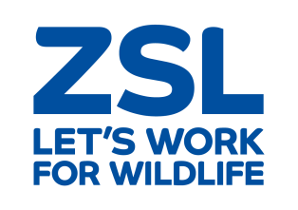

Job Description

Job Title: Marketing Executive

Department: Marketing

Directorate: Zoos and Engagement

Responsible to: Marketing Manager ZSL London Zoo

Approved by:

Head of Department / Director: Penny Hamilton / Nigel Campbell

Job Evaluation Committee Reference Number:

Grade Allocated: 6.1

Date Allocated:

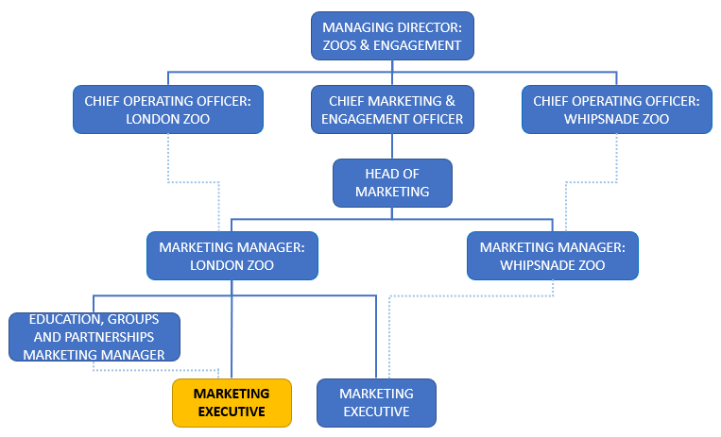

Job Description

Key Purpose of the Job
The Marketing Executive will be responsible for supporting the planning and implementation of marketing campaigns for ZSL London Zoo and ZSL Whipsnade Zoo. Significantly, this includes leading on marketing support for ZSL’s community engagement and outreach programme.

Main duties and key responsibilities
- Support ZSL’s education marketing programme through effective media planning, creative development and stakeholder management.
- Develop and implement the marketing strategy for ZSL’s community engagement and outreach programme (including the HLF Snowdon Aviary Restoration Project), including the identification and exploitation of appropriate channels, positioning, tone of voice and creative execution for the relevant audiences and activities – including internal communications to raise awareness of the HLF Project.
- Work closely with ZSL’s Community & Learning team to maximise the impact of partnership marketing, especially through charity and community stakeholders.
- Lead the development of marketing materials to promote the community engagement and outreach programme, including supporting other ZSL teams with their requirements, managing a range of internal and external suppliers.
- Work in collaboration with internal and external stakeholders, particularly the Community Engagement team and Communications colleagues, to ensure successful delivery of the marketing plan for the HLF project, including key milestones, appropriate reporting and influencing the future evolution of Project activities.
- Manage the pricing and distribution of tickets under ZSL’s Community Access Scheme, working with Discovery & Learning, Supporter Contact team and IT to efficiently allocate and distribute the free and subsidised tickets each year.
- Be an active member of ZSL’s Access Steering Group, representing the Marketing team and championing the voice of the consumer.
- Support the Groups, Trade, Promotions & Education Manager with ZSL’s trade partnerships, bulk ticket scheme, promotions and group sales.
- Be a champion for ZSL’s brand and audience segmentation, helping other departments to understand its value and importance.

The role will also be a key representative at the following:
- Meetings with community and charity partners, and ZSL’s trade partners
- Inbound and domestic travel trade shows
- Media and creative agency meetings
- ZSL team and project meetings
- ZSL Community & Learning updates

The role will be responsible for KPI reporting on a regular basis:
- Community engagement and outreach programme ticket distribution.
- Working with colleagues in Community & Learning to monitor costs to ensure cost neutrality or cost recovery as appropriate, and sustainability, across the Community and Outreach Programme.
- Regular formal and informal reporting on marketing activity plans to Community & Learning, Groups/Trade/Promotions/Education Manager, Zoo Marketing Managers, Head of Marketing, CMEO, Zoo COOs, Commercial & Communications Director and ZSL Council.
- Admissions/sales and revenue reporting on:
- Education visitors
- ZSL’s community engagement and outreach programme
- Groups visitors
- Trade partnerships
- Consumer promotions
- Bulk tickets

This role is responsible for day-to-day planning of marketing expenditure in support of the Community Access Scheme (c.£60k), although sign-off decisions sit with the London Zoo Marketing Manager.
It also contributes to the Zoos’ admissions revenue budgets for education, groups and partnerships.

Building relationships

The Marketing Executive will have key relationships with multiple stakeholders including:
- Charity and community partners.
- Trade partners.
- Internal departments – Community & Learning, Fundraising, Digital Content, Press, Creative Studio, Commercial and Zoological.
- External Media and Creative Agencies where appropriate

The job holder will need to have a confident and enthusiastic approach and be able to engage in high level meetings across ZSL and with third parties. The ability to influence and listen will be crucial. The Marketing Executive will need to be able to conduct themselves professionally at all times when representing ZSL.

Mental Demands
Major decisions with cost implications will be discussed with the London Zoo Marketing Manager, but the job-holder should be able to make informed recommendations and effectively assess diverse and potentially complex requirements from multiple stakeholders. They will need to judge how to handle each contact depending on their needs.
They will need to be able to manage their workload across multiple areas and prioritise effectively, and clearly communicate this to their line manager and other stakeholders. A high level of attention to detail is required, particularly when planning and implementing budget control.

Flexibility
The job holder will have to have a flexible approach to work and be able to manage changing deadlines and multiple projects.
As many key stakeholders are involved externally and internally the ability to gather feedback at appropriate times will be essential.

Working Conditions

- The job will be office based in London as part of the central Marketing Team
- There may be occasional travel to meetings or events in the UK

Expectations of job holder

- To ensure effective quality control and continuous improvement in all aspects of the work and responsibilities attached to this post.

- Demonstrate professionalism towards sensitive and confidential information.

- To comply with and promote Health and Safety policies and procedures and to undertake recommended Health and Safety training as and when necessary.

- To be committed to professional self-development, through participation in in-service training as necessary for the successful carrying out of the job.

- To undertake such other duties as are commensurate with the grade of the post.

- To ensure that the policy for equality of opportunity is adhered to and promoted in all aspects of the post holder’s work.

NB: This job description is designed to outline a range of main duties that may be encountered. It is not designed to be an exhaustive list of tasks and can be varied in consultation with the post holder in order to reflect changes in the job or the organisation.

Person Specification

The post holder will need to be an enthusiastic and confident individual who has the ability to get people on side. They will be passionate about marketing and communications and be able to identify new opportunities and bring new ideas to the team.

They will need to be professional in approach and be able to confidentially articulate ideas. A creative thinker would be beneficial and certainly the ability to be able to critically review creative and strategy.

Qualifications & Experience
- Educated to degree level with an additional marketing or tourism qualification desirable.
- Proven knowledge of Marketing and practical experience of developing marketing strategy and project management.
- Experience planning, implementing, monitoring and reporting on multi-channel campaigns. This should include offline and online media channels including print, DM, out-of-home, email marketing and PPC.
- Copywriting experience and hands-on digital marketing – including CMS management, paid social campaigns and digital analytics – would be a distinct advantage.
- Experience developing creative and working with spreadsheets is essential, as is a good level of numeracy.

Knowledge
- Knowledge of visitor attractions (e.g. museums, galleries, heritage and leisure sites), with knowledge of their education and community programmes desirable.
- Knowledge of commercial marketing and disciplines.
- Knowledge of project management.

Skills & Abilities
- An ability to manage competing priorities.
- Ability to work well in cross-functional teams as a representative of the marketing team and effectively communicate with different stakeholders.
- The role will need to work autonomously at times and the post holder should be able to be self-motivated and driven.
- Experience in managing the creative process including amends, feedback, copy and design quality checking and approvals process.
- Financial awareness and ability to report figures.
- Advanced skills in using MS office packages, specifically Excel and PowerPoint.

Other Requirements
On rare occasions weekends or evenings may need to be worked.

