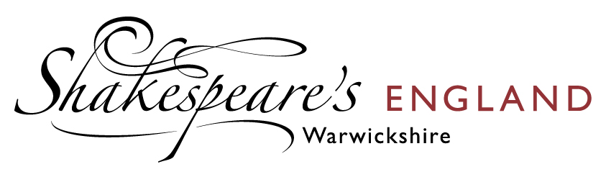
Job Description

Business Development Manager

Shakespeare’s England, the Destination Management Organisation (DMO) for South Warwickshire and surrounding region, is looking for an experienced Business Development Manager to increase its membership portfolio, provide one to one support for the existing membership and seek new commercial opportunities. This is an exciting opportunity for someone who wants to make a difference in ensuring the tourism and hospitality sector of Warwickshire, bounces back better.

Purpose of role
The Business Development Manager will be responsible for recruiting new Business Tourism and Leisure Tourism Members to Shakespeare’s England. Clearly identifying the benefits received from being part of the Destination Management Organisation. They will be expected to hit quarterly recruitment targets and provide monthly update reports.

The BDM will also be responsible for retaining the existing membership, providing Key Account Management services and ensuring all Members maximise their Membership opportunities. Including but not limited to signing them up to the Explorer Pass by Shakespeare’s England; Stay, Play, Explore-Warwickshire; the Shakespeare’s England closed user Facebook Group and TXGB.

This is a new role for Shakespeare’s England and as such it is an ideal opportunity for a self- motivated and driven individual to help shape, grow and future-proof this membership organisation by seeking out new commercial/partnership opportunities and identifying ways that Members can work more collaboratively for the benefit of all. The BDM will also be responsible for the development and implementation of a robust CRM programme and the development of the DMO’s Events programme, working alongside Shakespeare’s England Senior Marketing Manager and Social Media Executive.
.
Reporting directly to the Chief Executive, the BDM role is vital for the daily operation and growth of the organisation. Although initially offered on a 1 year fixed-term basis the aim is to identify this position as fundamental to the organisation’s long-term viability and thus the need for it to be made permanent.

Main duties and responsibilities
- To establish and maintain good relationships with members, develop and implement a regular communication programme and deliver against Members’ requirements.
- Making sure Members’ information on the Shakespeare’s England website is input, up to date and presented correctly.
- Establish and manage the SE CRM system
- Manage all aspects of administrative around new Members, supplying new Member information packs, and producing recruitment presentations and collateral.
- Meet new Member recruitment targets set by the Chief Executive.
- Develop a pipeline of target businesses for potential Membership
- Act as the day to day point of contact for Members and co-ordinate Members’ news
- Provide Senior Marketing Manager and Social Media Executive with Members’ news for the website, newsletters and SM posts.
- Upsell benefits to move Members from lower to higher membership levels and sell bespoke mailing opportunities, website advertising and paid-for events.
- Deal with day-to-day enquiries from members, non-members, and stakeholders.
- Develop a Members Event Programme and work with colleagues on the delivery of the Quarterly Tourism Forums, face to face, virtual or hybrid.
- Provide the CE with a monthly membership report and quarterly input report for the Shakespeare’s England Board Meeting.
- Act as a Brand Ambassador for the DMO and attend Trade and Consumer Shows (Leisure and Business Travel) as and when required.
- Deputise for the Chief Executive at meetings and/or events as and when required.
- This job description is not intended to be exhaustive, and the post holder will be required to undertake any other duties as directed by the Chief Executive.

Personal Specification
- Have a minimum of 2 years’ experience in a sales role.
- Experience in delivering and managing CRM systems.
- Are self-motivated, outgoing and comfortable liaising with people at all levels
- A reliable, committed team worker.
- Ability to work to tight deadlines.
- Good IT skills and experience of online communication
- Excellent written and oral communication
- Sympathetic to the needs of the inbound tourism industry
- Able to work on own initiative, highly organised, can manage own work-load and deliver against targeted goals.
- Good presentation skills and confident addressing an audience.
- Confident in liaising with industry partners and developing partnerships.
- Proven budget management, and able to confidently negotiate contracts.
- Access to own transport, living in or within a 1-hour drive of South Warwickshire.
- Comfortable with flexible working hours.

Additional Information
This is a fantastic opportunity to work with a leading international tourist destination. Shakespeare’s England, (DMO) was registered in 2012 and is a private sector led, not for profit membership organisation. It has the support of some of the most famous names in English tourism – The Royal Shakespeare Company, The Shakespeare Birthplace Trust and Warwick Castle. It also has the support of Stratford and Warwick District Councils and is accredited by VisitEngland/ VisitBritain.

If you believe you meet the criteria and are keen to make a difference please email your CV and a covering letter to Helen Peters, Chief Executive, Shakespeare’s England helen@shakespeares-england.co.uk or discuss call Helen on 07469 159499.

Salary £28,000 per annum

The closing date for applications is Friday 14th May 2021.

